Welcome to Class One
Autumn Term
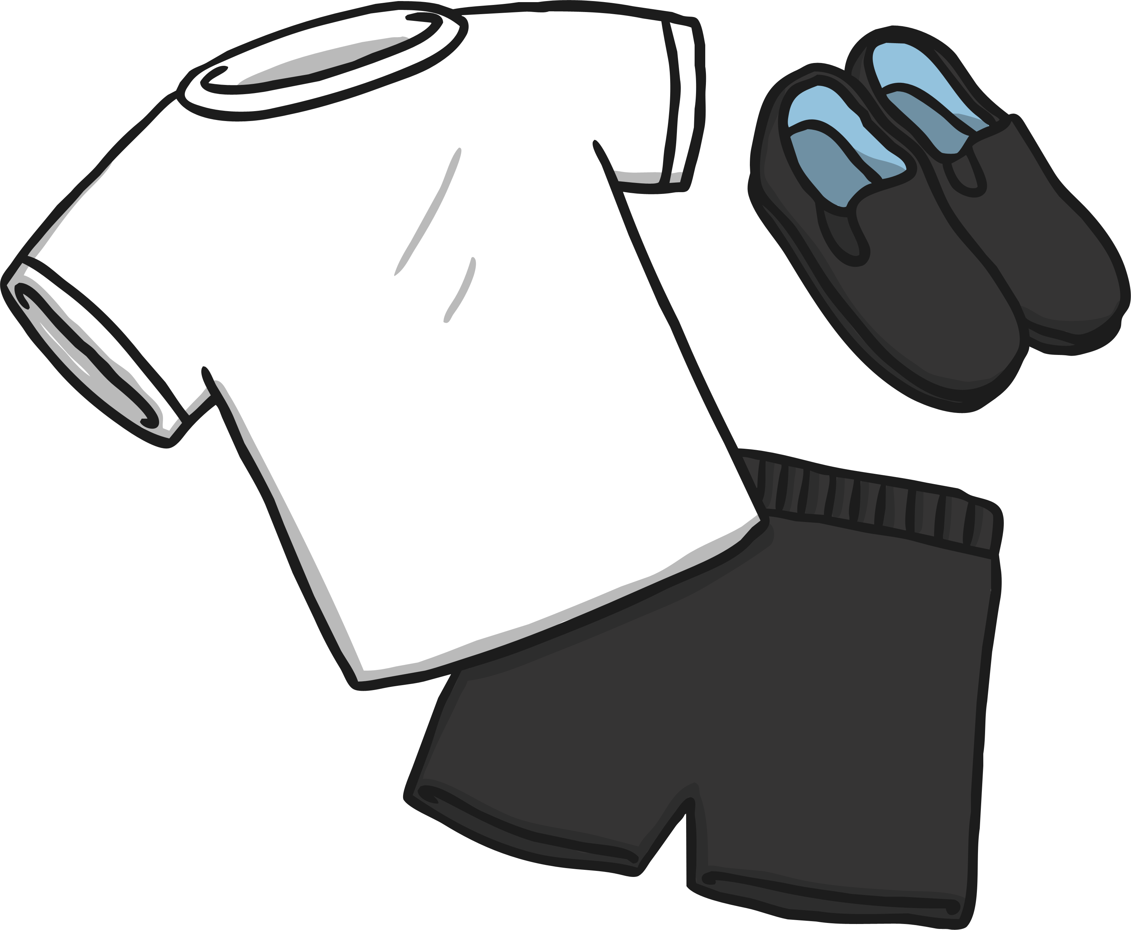
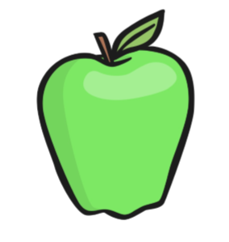
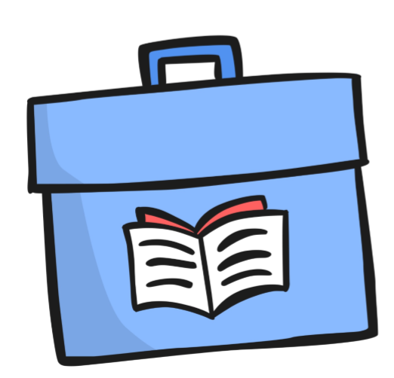
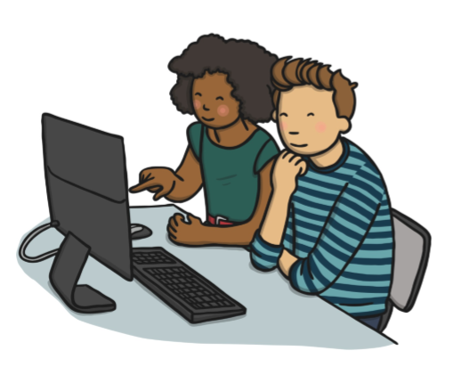
A quick introduction to our team in Class One: Miss Odenrode will be the class teacher and our wonderful teaching assistant is Mrs Wilkinson.
Snack
A tuck shop is available daily with
items including: yoghurts, fruit and breadsticks. This costs £1 a week and can be brought in on Mondays or paid in advance for each half term. Fresh water will also be provided for the children to keep hydrated.

P.E.
P.E. is taught during one afternoon
each week. Children need to have a
plain red t-shirt, black/navy short and pumps
in a bag. This will be left
on their peg until the end of each half term,
when we will send it home for you to wash & check the fit. Children should not wear earrings for P.E. - please take them out at home as we are not able to do this in school.
Please can you clearly label all your child’s P.E kit and uniform with their name.
Reading
Your child will need to bring their book bag
everyday. Please check it daily for letters.
We will listen to your child read individually
and change his/her book at least fortnightly. We will write comments for you in the reading record book, which should be kept in their book bag. Please listen to your child practise reading for a few minutes each day, if possible and sign the reading record when you’ve read together.
Each child will also read in school within a guided reading group where they will be challenged and moved on with their reading!
Friday Assembly
On a Friday we have a whole school award assembly where the children can bring in new certificates, awards, badges and trophies that they may have earned outside school. So if they want to share their achievements, please send them into school on a Friday.
Our topics for this term
English: Stories with a familiar setting, and fiction and non-fiction writing.
Mathematics: Place Value within 10, addition and subtraction within 10, 2D and 3D shape.
Science: “Why are humans not like tigers?”
Topic: “What is it like where we live?” “Is London Burning?”
Homework
Your children will receive a homework booklet for each half term. This will contain spellings your child should practice weekly along with a piece of English and Maths work. Instructions on how to complete homework will be at the front of your child’s homework booklet.

Homework will set sent out on a Friday and collected in on a Wednesday.
Useful links
There are lots of websites with
activities and games to help
you to help your child at home.
We recommend:
http://www.bbc.co.uk/bitesize/ks1/
www.ictgames.com www.topmarks.co.uk and http://www.phonicsplay.co.uk/

